EXPERIMENT 15 PPS: Car dealership

sales system
- ALGORITHM:
Step 1: Start
Step 2: Define a base class Car
  - Declare attributes: brand, price, model, color
Step 3: Define constructor init()
  - Initialize all attributes using input values
Step 4: Define method display_details()
  - Print brand, price, model, and color (each on separate line)
Step 5: Define derived class Car1
  - Inherit from class Car
  - Override method display_details() to print details
Step 6: Define derived class Car2
  - Inherit from class Car
  - Override method display_details() to print details
Step 7: Read input for first car
  - Store values: brand1, price1, model1, color1
Step 8: Read input for second car
  - Store values: brand2, price2, model2, color2
Step 9: Create object car1 of class Car1
  - Pass first car details
Step 10: Create object car2 of class Car2
  - Pass second car details
Step 11: Call display_details() for car1
  - Print first car details
Step 12: Call display_details() for car2
  - Print second car details
Step 13: Stop B]FLOWCHART:

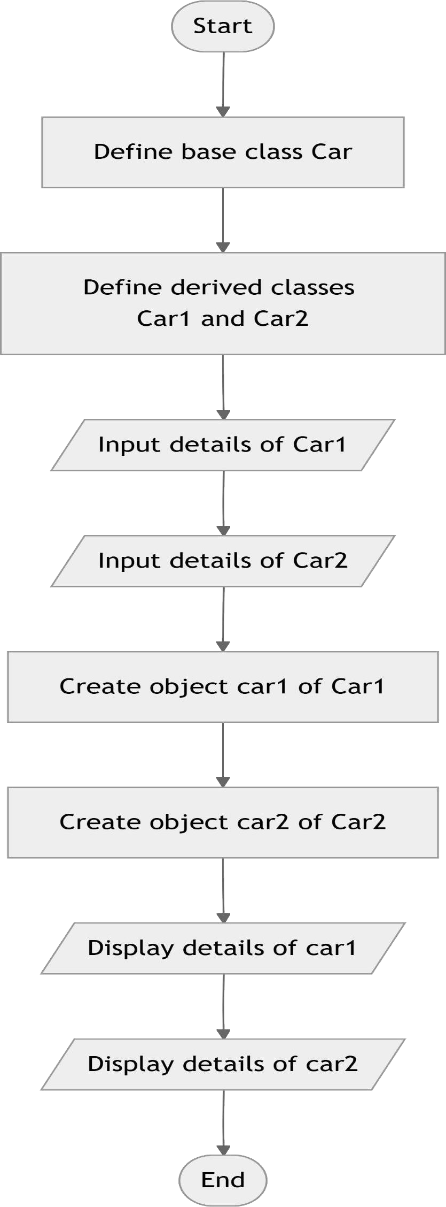
C]CODETANTRA:

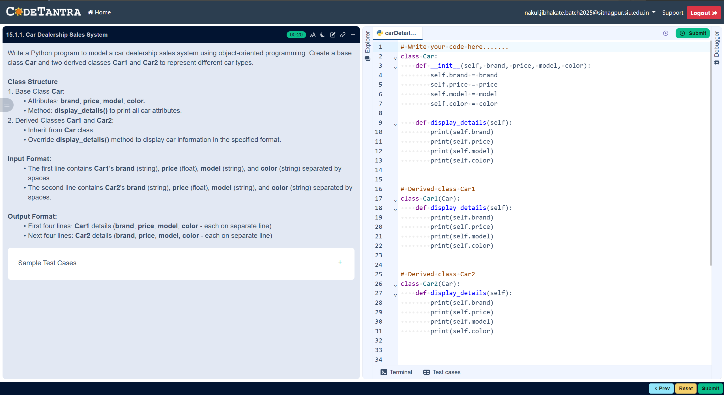
D] code: class Car:
def init (self, brand, price, model, color):
self.brand = brand self.price = price self.model = model self.color = color

def display_details(self): print(self.brand) print(self.price) print(self.model) print(self.color)

# Derived Class Car1 class Car1(Car):
def display_details(self):

print(self.brand) print(self.price) print(self.model) print(self.color)

# Derived Class Car2 class Car2(Car):
def display_details(self):
print(self.brand) print(self.price) print(self.model) print(self.color) #
Read input car1_data = input().split()
brand1, price1, model1, color1 = car1_data[0], float(car1_data[1]), car1_data[2], car1_data[3]

car2_data = input().split()
brand2, price2, model2, color2 = car2_data[0], float(car2_data[1]), car2_data[2], car2_data[3]

# Create objects car1 = Car1(brand1, price1, model1, color1) car2 = Car2(brand2, price2, model2, color2)

# Display details car1.display_details() car2.display_details()

